Insulation Panel Research

# Insulation Panel Test

## Procon Masterpanel

Figure : Start - Heater on

Figure : 5:45 - Heater on

Figure : 100c – Heater Off at 12 min mark

Figure : 15min - Heater off

Figure : 21:45 - Heater Off

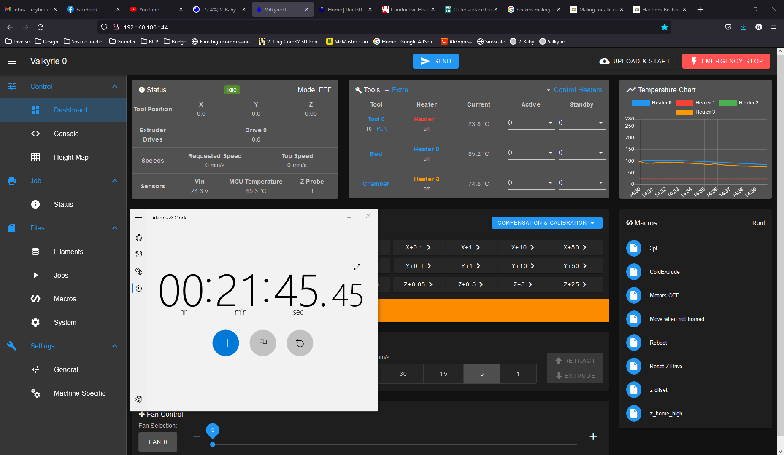

Figure : 30 min - Heater Off

Figure : 1h - End of test

